1. whoami 🡪 To get the username

1. ls 🡪 to list the directories
2. 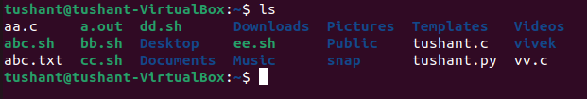
3. ls -al 🡪 List the directories including hidden and with other details

1. pwd 🡪 To see the directory you are currently working with

1. cd <directory name> : To enter the directory

1. cd .. 🡪 To go to the previous directory

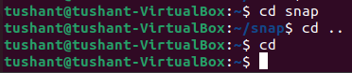

1. cd 🡪 To go to home directory

1. touch <file name> 🡪 To create a file

1. vi / nano 🡪 Open the writing mode

vi

nano

1. vi / nano <file name> 🡪 create a file and open in writing mode

1. cat <file name> 🡪 To read file and add content(cat >> filename)

1. mkdir<directory name> 🡪 create a directory



1. mkdir -help 🡪 help in mkdir

1. mkdir -v <directory name> 🡪 create a directory and give output for status



1. mkdir -p <directory name/next directory> 🡪 Create a directory path
2. Text

   Description automatically generated
3. rm <file name> 🡪 to delete a file, rmdir <directory name> 🡪delete directory

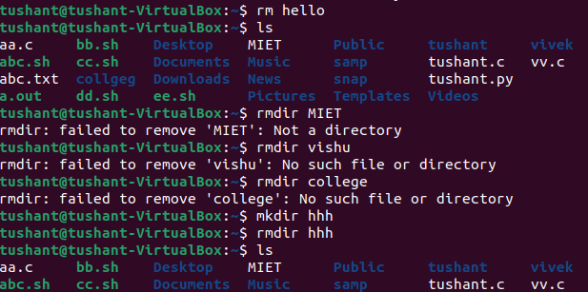

1. mv <old file name> <new file name> 🡪 to renaming a file

